2007 Municipal Energy Use and
Greenhouse Gas Baseline Report for
Cape Elizabeth, Maine




Prepared for the Town of Cape Elizabeth, Maine
by the Greater Portland Council of Governments
with assistance from Clean Air-Cool Planet
January 2010

Contents
Summary 2
Introduction & Methodology 3
Municipal Overview 5
Building Performance: Energy Use, Emissions, Costs 7
Vehicle Performance: Energy Use, Emissions, Costs 16
Streetlights: Energy Use, Emissions, Costs 19
Priorities and Recommendations 19

Summary

This report is a summary of greenhouse gas emissions and energy use for the Town of Cape Elizabeth, ME for the year 2007. The focus of this report is the municipal operations of the Town, with special emphasis on Town-owned buildings. It does not encompass residential, commercial, or industrial energy use. The Greater Portland Council of Governments (GPCOG) prepared this report using data collected from various sources within the town, including Ernie MacVane, Facilities Manager. Ben Lake, GPCOG intern, compiled and analyzed the data using Environmental Protection Agency (EPA) Portfolio Manager software and Clean Air and Climate Protection (CACP) software provided by ICLEI. Clean Air-Cool Planet provided advice and assistance throughout the process

Quick Facts

Town population: 9,165.
Area of municipality: 15 sq. mi.
Population density: 611 people per square mile.
GPCOG region total population: 250,000 (2007 estimate).
Municipal population as a percent of GPCOG: 3.7%.
Total area of municipal building space: 562,219 sq. ft.
Average site energy intensity of all municipal buildings: 62 kBtu/sq. ft.
Number of streetlights: 499 (reduced to 372 in July, 2009)
Number of vehicles in fleet: 75.
Total cost of municipal energy use in 2007: $836,909.
Total municipal energy use in 2007: 41,781 MMBtu.
Total municipal greenhouse gas emissions in 2007: 3,586 tons (metric tons).

Introduction & Methodology

In August 2007, the Cape Elizabeth Town Council established a Cape Elizabeth Alternative Energy Committee to “explore opportunities to provide alternative energy to municipal and school buildings and vehicles.” The Town appointed members to the Alternative Energy Committee in October 2007.

In December 2008, the Alternative Energy Committee completed a report, which examines various alternative energy and conservation options and makes recommendations for the most cost-effective methods to reduce the Town’s energy use and carbon footprint. Recommendation 7 is to “Participate with GPCOG in completing the ICLEI – Local Governments for Sustainability – Regional Assessment.”

GPCOG is a member of ICLEI’s Cities for Climate ProtectionTM (CCP) Campaign, which helps local governments adopt policies and implement measures to reduce greenhouse gas emissions. ICLEI’s CCP Campaign uses five milestones to structure the process and keep local governments on track: 1) conduct a baseline emissions inventory and forecast; 2) adopt an emissions reduction target; 3) develop a local action plan to meet the target; 4) implement the policies and measures within the local action plan; and 5) monitor and verify results.

This report is written in partial fulfillment of milestone 1), conduct a baseline emissions inventory; and 3), develop a local action plan.

Knowledge and understanding of how energy is being used for municipal activities is valuable because it allows towns to examine their facilities, vehicles and activities for potential improvements in efficiency, as well as opportunities to use alternative energy. With this baseline, Cape Elizabeth will also be able to calculate energy and emissions savings from energy efficiency improvements and alternative energy projects.

Cape Elizabeth is one of two pilot towns receiving a pro bono greenhouse gas and energy inventory from GPCOG. Funding permitting, GPCOG hopes to assist all 26 towns in the region in completing energy and emissions inventories. This is the first step in implementing GPCOG’s recently adopted Sustainability Principles, the first of which states, “A sustainable Greater Portland Region is one that uses non-renewable resources sparingly, renewable resources at a sustainable rate, and in a continuous cycle.”

Data Collection & Analysis

Data for this report was collected by numerous sources within the Town of Cape Elizabeth, including Ernie MacVane (Facilities Manager), Robert Malley (Public Works Manager), Sandy Brown (Accounts Payable Supervisor) and Pauline Aportria (School Business Manager). To process the data collected, GPCOG staff and interns used two types of fuel and energy assessment software. ICLEI’s Clean Air and Climate Protection (CACP) software quantifies the amount of energy used and the greenhouse gases (GHG) generated from the energy usage. EPA Portfolio Manager Benchmarking Program supplemented CACP software by providing additional information on building energy use.

The Clean Air and Climate Protection Software

The CACP software estimates the following air pollutants from energy consumption data:

CO2: Carbon Dioxide
N2O: Nitrous Oxide
CH₄: Methane

To simplify the data output, the program converts these gases into one CO2 equivalent (CO₂e) value according to the relative greenhouse effect of each gas. For example, N₂O is about 310 times more potent than CO2 as a greenhouse gas, so the program multiplies the mass of N2O by 310 to obtain the CO2 equivalent value. CH₄ is approximately 21 times more powerful than CO₂. CO₂e provides a useful measure of greenhouse gas emissions because it incorporates all greenhouse gases into a single, uniform unit.

The CACP software is divided into two primary categories: municipal government and community. Government analysis includes all municipal-owned facilities, properties, equipment, buildings, and operations. Community analysis includes everything within the town limits (including the government). This report focuses on municipal government operations.

Municipal Overview

The CACP municipal analysis generates greenhouse gas emissions data for government operations. The municipal analysis only includes facilities under municipal control. For example, since Cape Elizabeth’s water and sewage is not under its direct control, it is not included in the body of this report.

This municipal analysis is divided into three categories:

• Buildings: Emissions resulting from municipal buildings
• Vehicle Fleet: Emissions resulting from city owned vehicles
• Streetlights: Emissions resulting from electricity generation for street and traffic lights

Municipal Sector | Energy Use  (MMBtu) | Energy Use  (%) | GHG emissions  (tons CO₂e) | Portion of total GHG emissions  (%) | Energy Cost  (US$) | Portion of Total Energy Cost (%)
Buildings | 34,007 | 81.40% | 2,983 | 83.18% | $666,575 | 79.64%
Vehicles | 7093 | 16.97% | 518 | 14.45% | $105,427 | 12.60%
Street Lights | 681 | 1.63% | 85 | 2.37% | $64,907 | 7.76%
Total | 41,781 | 100.00% | 3,586 | 100.00% | $836,909 | 100.00%
Table 1. 2007 municipal energy use, greenhouse gas emissions (CO₂e), and costs, by sector

Table 1, above, shows a summary of each category’s energy consumption, CO2 equivalent emissions and cost. The following graphs show the relative energy use, greenhouse gas emissions and cost by sector.

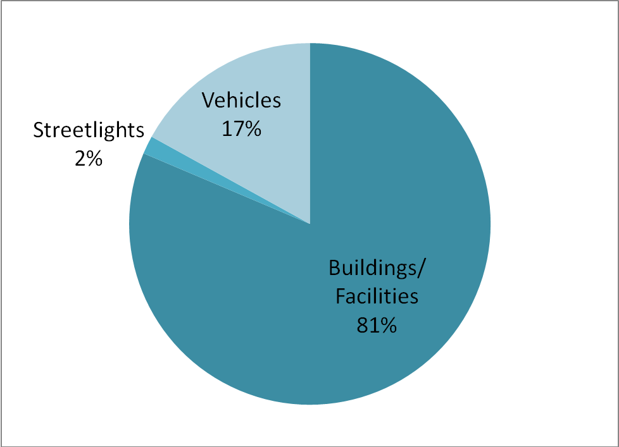
Graph 1a. 2007 Municipal Energy Use
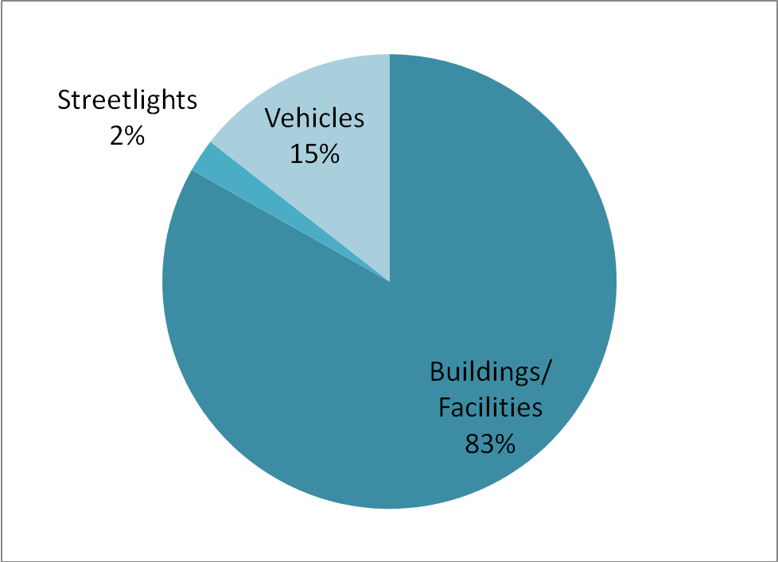
Graph 1b. 2007 Municipal Greenhouse Gas Emissions

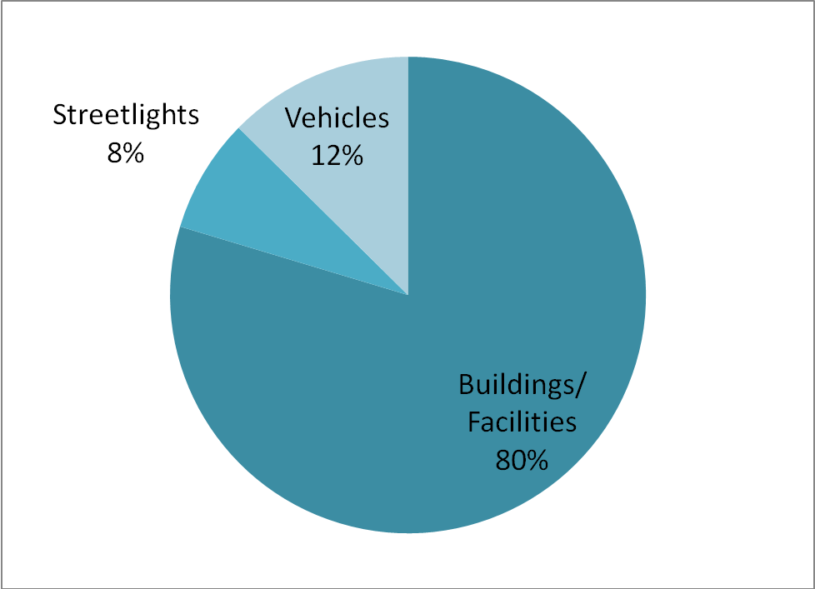
Graph 1c. Annual Energy Costs by Municipal Sector

The majority of municipal emissions and energy costs were due to electricity and fuel consumption in municipal buildings and facilities (~80%). Vehicle fleet operations accounted for 17% of energy use and 15% of emissions. Operation of streetlights represented a small portion of energy use and emissions generation, but accounted for a relatively larger portion of energy costs to Cape Elizabeth – 8%. Note the clear positive correlation between energy use, emissions, and relative energy expenditures.

Building Performance: Energy Use, Emissions, Costs

Data on electricity and fuel use for each municipal building were gathered and analyzed in CACP software. The following table shows energy use, greenhouse gas emissions and cost data for individual buildings, calculated using the CACP software. Graphs below illustrate the relative energy use, emissions, and costs among the buildings and facilities under the municipal jurisdiction.

The high school (HS), middle school (MS), elementary school (ES) and pool share meters – the three schools share an electricity meter, and the pool and the high school share fuel, as do the elementary and middle schools. Unfortunately, this muddies picture of the energy consumption and emissions for individual buildings. While they are included in the table below, the schools and pool are not included in subsequent graphs because together they account for approximately three quarters of the total building and facility energy use, emissions and cost, thus dwarfing the contribution of the other buildings and facilities. Instead, they are dealt with separately in their own section, below.
Name of Building | Energy Use (MMBtu) | Portion of Overall Municipal Energy Use (%) | GHG emissions (tons CO₂e) | Portion of Overall Municipal GHG emissions (%) | Energy Cost (US$) | Portion of Overall Municipal Energy Cost (%)
Cape Cottage Fire Station | 174 | 0.42 | 15 | 0.42 | $3,964 | 0.47
Community Services | 1,298 | 3.11 | 111 | 3.10 | $25,292 | 3.02
Day One | 135 | 0.32 | 10 | 0.28 | $3,271 | 0.39
Family Field* | 0 | 0.00 | 0 | 0.00 | $83.00 | 0.01
Fort Williams Park | 323 | 0.77 | 26 | 0.73 | $6,206 | 0.74
HS, MS, ES and Pool | 26,648 | 63.78 | 2,342 | 65.33 | $494,410 | 59.08
Lions Field | 13 | 0.03 | 2 | 0.06 | $664 | 0.08
Plaisted Park | 6 | 0.01 | 1 | 0.03 | $388 | 0.05
Pond Cove Rental Units | 20 | 0.05 | 2 | 0.06 | $890 | 0.11
Portland Head Light Museum/Gift Shop | 221 | 0.53 | 20 | 0.56 | $5,684 | 0.68
Public Works Department | 1,246 | 2.98 | 108 | 3.01 | $29,136 | 3.48
Rear Town Hall (Utility Garage) | 5 | 0.01 | 1 | 0.03 | $349 | 0.04
Riverside Cemetery* | 2 | 0.00 | 0 | 0.00 | $189 | 0.02
Salt Shed* | 0 | 0.00 | 0 | 0.00 | $139 | 0.02
Shore Road Ice* | 1 | 0.00 | 0 | 0.00 | $143 | 0.02
Skating Pond* | 0 | 0.00 | 0 | 0.00 | $134 | 0.02
Spurwink Church | 176 | 0.42 | 13 | 0.36 | $3,160 | 0.38
Thomas Memorial Library | 1,011 | 2.42 | 87 | 2.43 | $23,947 | 2.86
Town Center Fire and Police Stations | 1,887 | 4.52 | 166 | 4.63 | $45,107 | 5.39
Town Hall | 783 | 1.87 | 72 | 2.01 | $18,899 | 2.26
Transfer Station/Recycling | 56 | 0.13 | 7 | 0.20 | $4,520 | 0.54
Total | 34,005 | 81.39 | 2,983 | 83.21 | $666,575 | 79.65
Table 2. 2007 energy use, greenhouse gas emissions, and costs, by municipal building / facility

*Certain facilities marked above consumed relatively small quantities of electricity during the 2007 calendar year. These values have been included in the overall analysis, but due to rounding, it may appear that these facilities did not consume any energy or produce emissions.

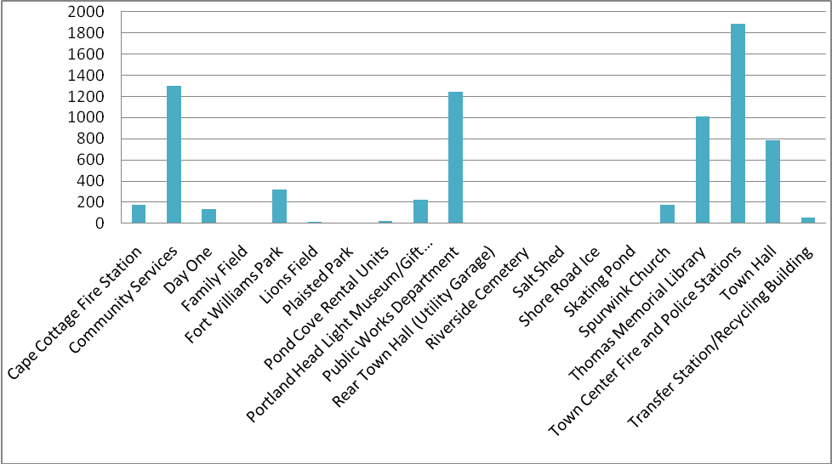
Graph 2a. Annual Energy Use by Facility (MMBtu)

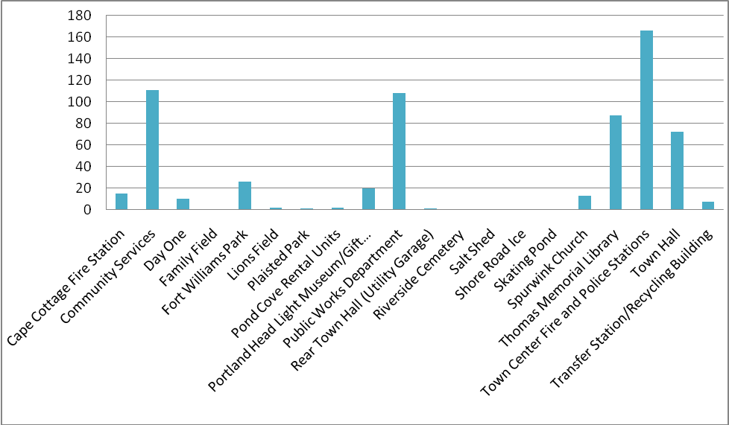
Graph 2b. Annual Carbon Equivalent Emissions by Building (tons)
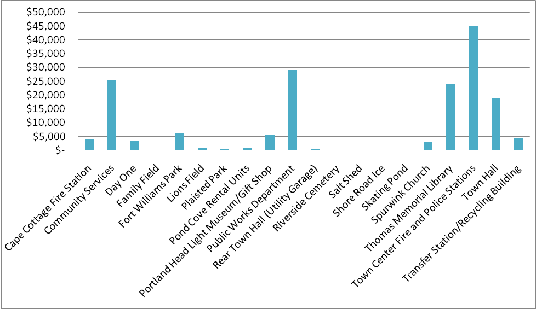
Graph 2c. Annual Cost by Building ($)

The majority of energy use, emissions and costs are due to the schools and pool, which are not shown here, but are discussed below. Other smaller but still relatively large energy consumers are the Fire and Police Stations, the Public Works Department, and Community Services, as shown above. Cape Elizabeth has a number of small buildings and facilities, which consume small amounts of energy. These are nevertheless important to include because together these small buildings and facilities (the Family Field, Lions Field, Plaisted Park, the Utility Garage, Riverside Cemetery, Salt Shed Shore Road Ice and the Skating Pond) cost nearly $3,000 in energy bills in 2007. It may be that some facilities do not need power or that separate facility functions could be combined to save resources.

Schools and Pool

Together, the high school, middle school, elementary school and pool accounted for 64% of total municipal energy use, 65% of municipal emissions, and 59% of municipal energy cost in 2007 – approximately two thirds of the total municipal profile (they accounted for three quarters of building energy profile). They are not included above because they share meters, so their relative impact dwarfs the other buildings. The graphs below show energy use, emissions and costs, as classified by meter. For future analysis, separate meters would yield a clearer picture of individual building performance.
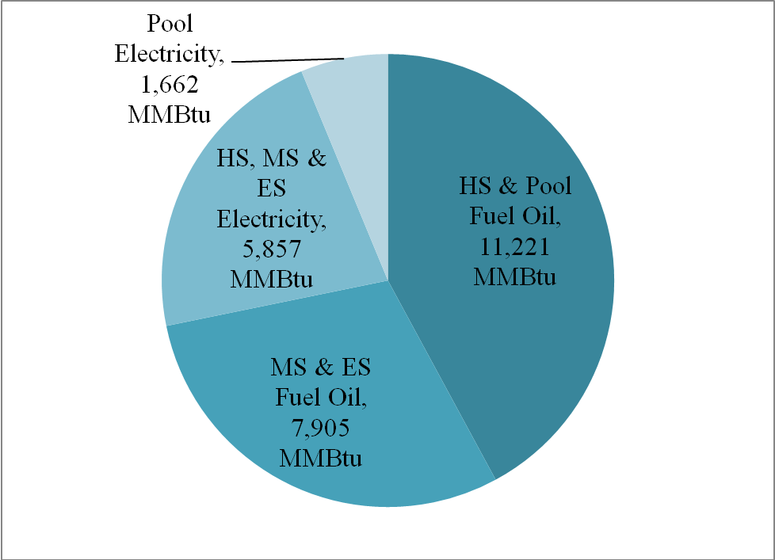
Graph 2d. Energy use (MMBtu) for the high school, middle school, elementary school and pool

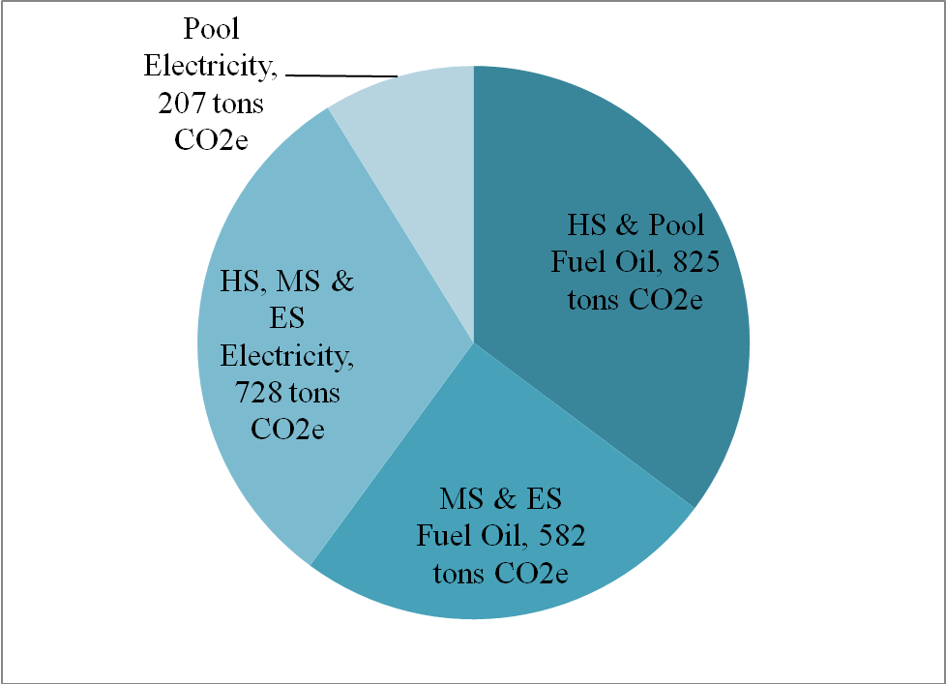
Graph 2e. Emissions (tons CO2e) for the high school, middle school, elementary school and pool

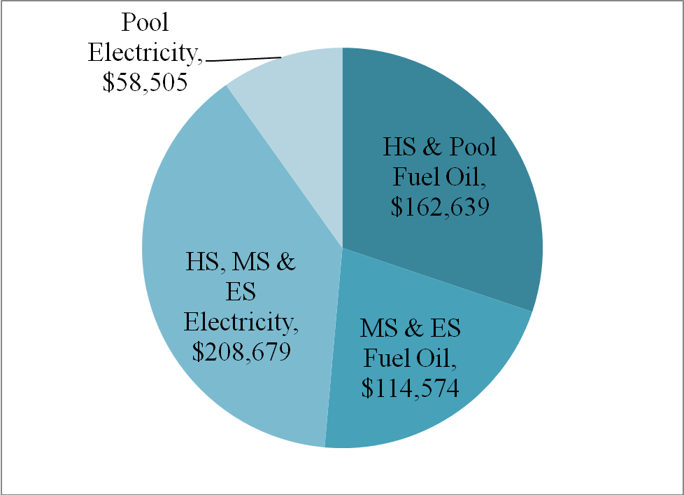
Graph 2f. Energy costs for the high school, middle school, elementary school and pool

The Cape Elizabeth Alternative Energy Report from December 2008 deals with the schools and the pool extensively, and rightly so; they represent two thirds of the Town’s energy use. As the Alternative Energy Report notes, the average electricity consumed per square foot in Maine schools is lower than in the Cape schools in 2007 – electricity efficiency improvements might be cost-effectively obtained. As identified in the report, the pool and schools’ fuel oil consumption may provide opportunities for cost-effective alternative fuel use. Woodchips were a recommended alternative.

Again, because the pool, high school, middle school and elementary school share meters, it is difficult to adequately analyze inefficiencies.

Building Energy Intensity

Energy intensity is one of the most powerful tools available for measuring the relative energy efficiency of particular buildings. Site energy intensity is calculated by taking the amount of energy used in the building (a total aggregate of heating fuel and electricity) and dividing it by the square feet of space. Greenhouse gas intensity is calculated by taking the amount of greenhouse gas emissions (measured in CO₂e) and dividing it by the amount of square feet of space. Both can be reduced through behavioral and energy conservation measures. The best opportunities for saving energy on site would involve behavioral changes (such as keeping lights and computers turned off; turning down thermostats) and energy conserving technologies (such as motion sensor lighting). Cost intensity is also measured per square foot and can provide a useful means for comparison.

Information about the energy intensity of Cape Elizabeth’s buildings was derived through EPA Portfolio Manager and CACP software. EPA Portfolio Manager provides national averages by building type as a benchmark, enabling comparison of building performance. CACP software provides information on greenhouse gas intensity. They both provide cost and energy use per square foot.

Only buildings are included in the table below. It does not include other facilities, such as playing fields. It also excludes buildings for which square footage information is missing, such as the Pond Cove Rental Units. Again, the high school, middle school, elementary school and pool are combined due to shared meters.

Name of Building | Type(s) heating fuel used | Area  (Sq. Ft.) | Site energy intensity (kBtu/sq ft) | EPA Average Site energy Intensity for building type (kBtu/sq ft) | GHG intensity (tons CO₂e/  1000 sq ft) | Energy cost /sq foot ($)
Cape Cottage Fire Station | Oil | 1710 | 101.8 | 78 | 8.77 | $2.32
Community Services | Oil/Propane | 34650 | 37.5 | 52 | 3.20 | $0.73
Day One | Oil | 3160 | 42.7 | 77 | 3.16 | $1.04
Fort Williams | Oil/Propane | 6828 | 47.3 | 65 | 3.81 | $0.91
HS, MS, ES and Pool | Oil | 439468 | 60.6 | 98.4 | 5.33 | $1.13
Portland Head Light/Gift Shop | Oil | 2860 | 77.3 | 82 | 6.99 | $1.99
Public Works Department | Oil | 14400 | 86.5 | 77 | 7.50 | $2.02
Rear Town Hall (Utility Garage) | None | 2600 | 1.9 | 25 | 0.38 | $0.13
Spurwink Church | Oil | 1680 | 104.8 | 25 | 7.74 | $1.88
Thomas Memorial Library | Oil | 15684 | 64.5 | 104 | 5.55 | $1.53
Town Center Fire and Police Station | Oil/Propane | 20475 | 92.2 | 78 | 8.11 | $2.20
Town Hall | Oil/Propane | 17454 | 44.9 | 77 | 4.13 | $1.08
Transfer Station/Recycling Building | None | 1250 | 44.8 | 77 | 5.60 | $3.62

Table 3. 2007 energy intensity by municipal building
Site energy intensity and EPA national average site energy intensity data generated by EPA Portfolio Manager software and CACP. Cost per square foot and CO₂e per square foot generated through CACP software.
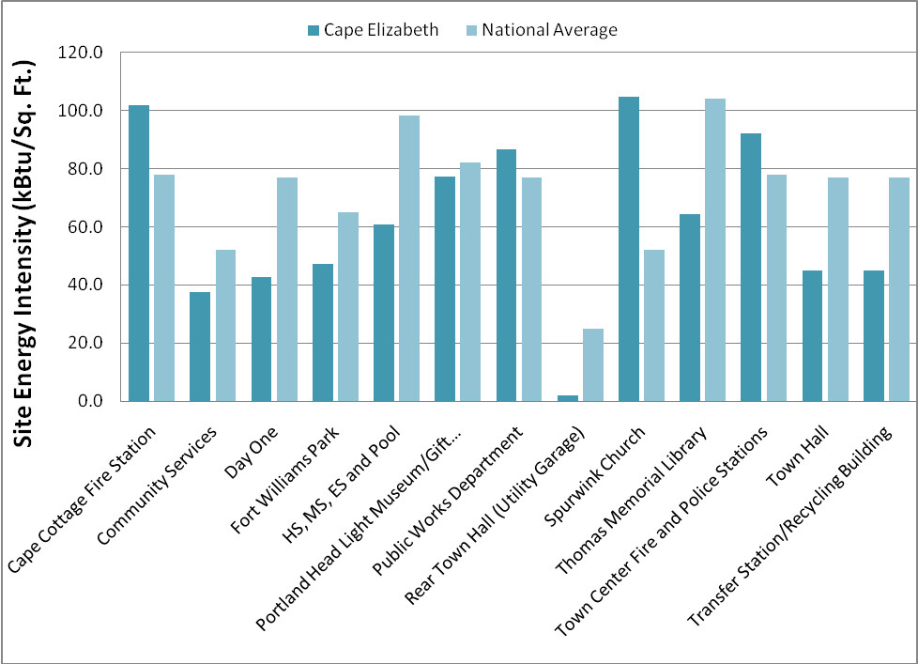
Graph 3a. Comparison of Cape Elizabeth and National Average Annual Site Energy Intensity by Building Type (kBtu/sq.ft.).

Graph 3a shows the energy intensity of Cape Elizabeth’s buildings as compared to national benchmarks developed by the EPA. While this provides a useful snapshot, its accuracy is variable for several reasons. Firstly, EPA lacks categories for all building types. For example, the Transfer Station/Recycling Building had to be classified as “other.” Furthermore, national averages may not provide a perfect comparison for Maine buildings, which are likely to have a higher heating, but a lower cooling load. Finally, national averages may not provide a perfect comparison for individual buildings that have unique attributes or functions. Nevertheless the above graph reveals areas worthy of attention.

Most of Cape Elizabeth’s buildings operate at energy intensities below the EPA’s national benchmark for that building class. This is good news for the Town, and is undoubtedly due to Cape’s substantial investment in energy efficiency, particularly the energy monitoring system, which allows precise control of building energy based on occupancy and other factors.

It is interesting to note that the schools performed as well as they did even though they include the pool. This may be due to the monitoring system and the addition of a smaller boiler, which is used during the summer months. This contrasts with the findings of the Alternative Energy Committee Report which shows the schools performing worse than the state average in terms of electricity use. These contrasting results may be explained by the fact that EPA Portfolio Manager combines electricity and fuel use, and compares all buildings based on total Btus. The Alternative Energy Report looked at electricity consumption alone. Because Cape Elizabeth has invested in the efficiency of the schools’ heating system, the schools may perform above the national benchmark in spite of electrical inefficiencies.

The two fire stations, the public works department, and Spurwink Church operate at higher site energy intensities than do buildings in the same class nationally. This may be a tip-off that inefficiencies exist. The Spurwink Church has the highest site energy intensity of any building. This is likely due to the fact that it was built in 1733. Spurwink Church is currently being renovated, which will hopefully improve its energy efficiency.

While the Day One facility appears to be considerably more efficient than the EPA national average for buildings of that class, only five months of energy use data (Feb-Jun 2007) were available (presumably due to its status as a Town rental facility). The Portfolio Manager software estimates and compares energy intensities based on energy consumption for an entire year. Day One’s energy efficiency is assessed based on five months of energy consumption for the entire year – its efficiency value relative to the national average is questionable.

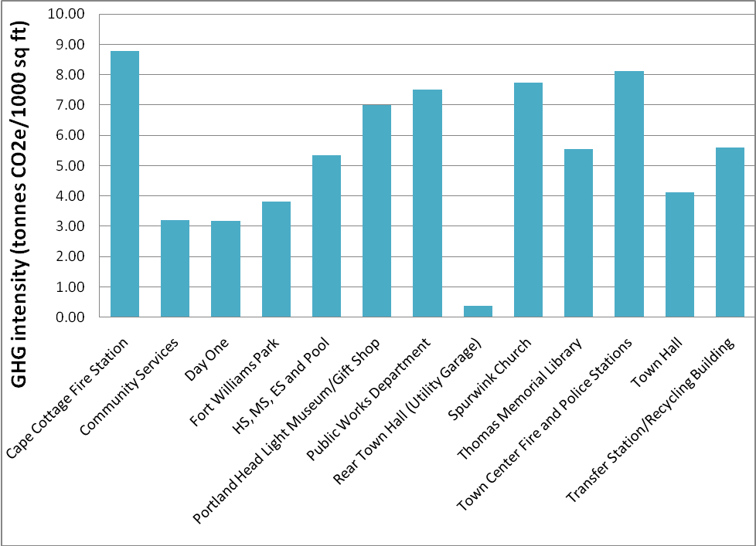
Graph 3b. Greenhouse gas site intensity, measured in tons of CO₂e per 1000 square feet
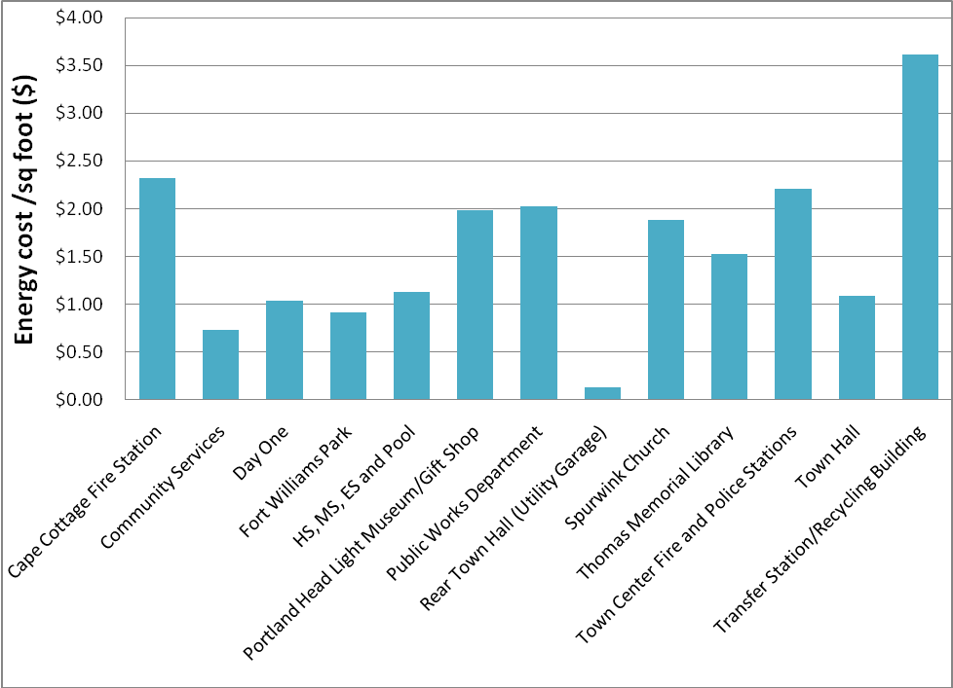
Graph 3c. 2007 average energy costs per square foot ($/sq.ft)

Graph 3b provides a comparison of the greenhouse gas emissions per 1000 square feet for municipal buildings. Graph 3c shows energy cost per square foot for each municipal building. Both can be used as a starting point in determining potential for increased cost savings and energy efficiency improvements.

The two fire stations and police station are the most greenhouse gas intensive buildings per square foot. There are a few potential explanations for this. Police and fire stations may have more extensive electronic equipment than a standard office or other facility. This equipment would likely run 24 hours per day, as opposed to most facilities, which are more likely to operate between 10-12 hours per day (consuming considerably less electricity as a result). Also, many fire stations have combined crew quarters and office space with large, tall garages and doors for engines and other equipment. The large spaces in these buildings may not be as tight as a standard office space of the same floor area, and so may require noticeably more fuel per square foot to maintain these buildings at a comfortable temperature. These buildings are less efficient than the national benchmark, however, so it may be that efficiencies could still be cost-effectively obtained. Efficiency investments in these buildings would likely yield substantial decreases in their greenhouse gas intensity.

The transfer station is the most cost-intensive building, costing Cape Elizabeth over $3.50 per square foot for energy use. There are multiple factors that may contribute to this building’s high cost intensity. It is the smallest building of those examined, and so its energy costs are more prone to appear magnified by a cost per square foot analysis. In addition, electricity provides both heat and lighting, and electricity is a more expensive form of energy. Finally, the reported cost/kWh for electricity consumed by the Transfer Station was over twice the cost/kWh for other buildings in Cape Elizabeth, at approximately 27 cents/kWh compared to 13 cents/kWh.

Vehicle Performance: Energy Use, Emissions, Costs

Cape Elizabeth’s vehicle fleet accounts for 17% of municipal energy use and 12% of energy cost. Energy, emissions, and cost data were broken down and analyzed based on department. Vehicle data for 2007 was sparse compared to data available for buildings. Because Cape Elizabeth keeps records based on fiscal year, fuel consumption for the calendar year 2007 was estimated by averaging consumption records for the years 2007 and 2008. Exact fuel expenditures were not tracked, so fuel costs were estimated based on the cooperative bid purchase price from the 2007 fuel supply period (April 1, 2007 to March 31, 2008).

Vehicle Type | Number of Vehicles | Energy Use (MMBtu) | Portion of Municipal Energy Use (%) | CO2e emissions  (tons) | Portion of Municipal CO2e emissions (%) | Energy Cost (US$) | Portion of Municipal Energy Cost (%)
Fire Dept | 10 | 426 | 1.02 | 31 | 0.86 | $6,361 | 0.76
Parks Dept | 10 | 404 | 0.97 | 29 | 0.81 | $6,444 | 0.77
Police Dept | 7 | 977 | 2.34 | 71 | 1.98 | $16,054 | 1.92
Public Works Dept | 30 | 2325 | 5.56 | 170 | 4.74 | $34,292 | 4.10
School Dept | 18 | 2961 | 7.09 | 217 | 6.05 | $42,275 | 5.05
Total | 75 | 7093 | 16.98 | 518 | 14.45 | $105,427 | 12.60
Table 4. Comparison of vehicle energy use, emissions and cost by type.

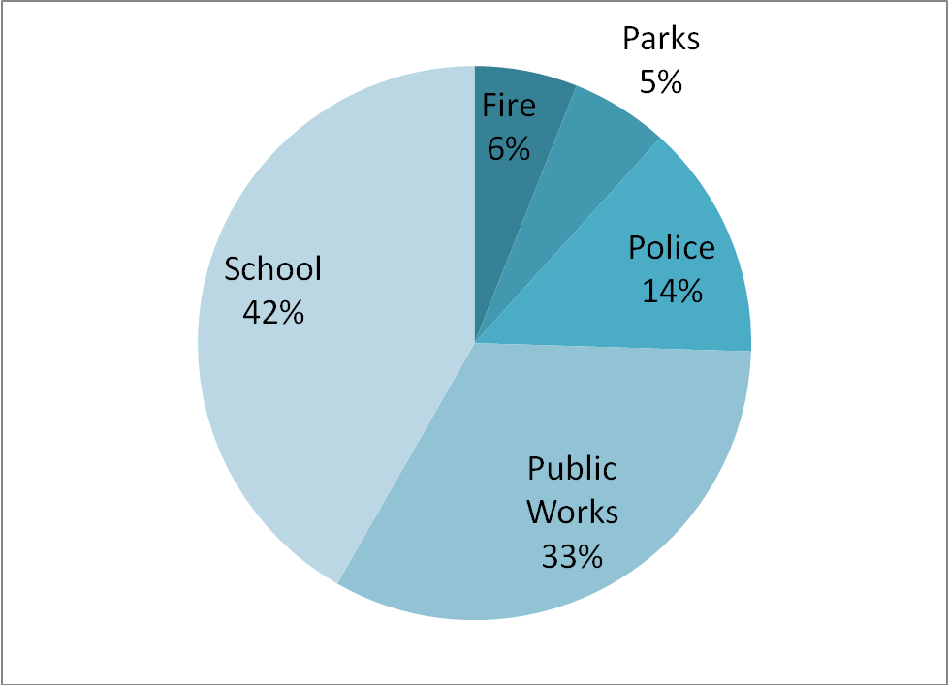
Graph 4a. Comparison of vehicle energy consumption by department.

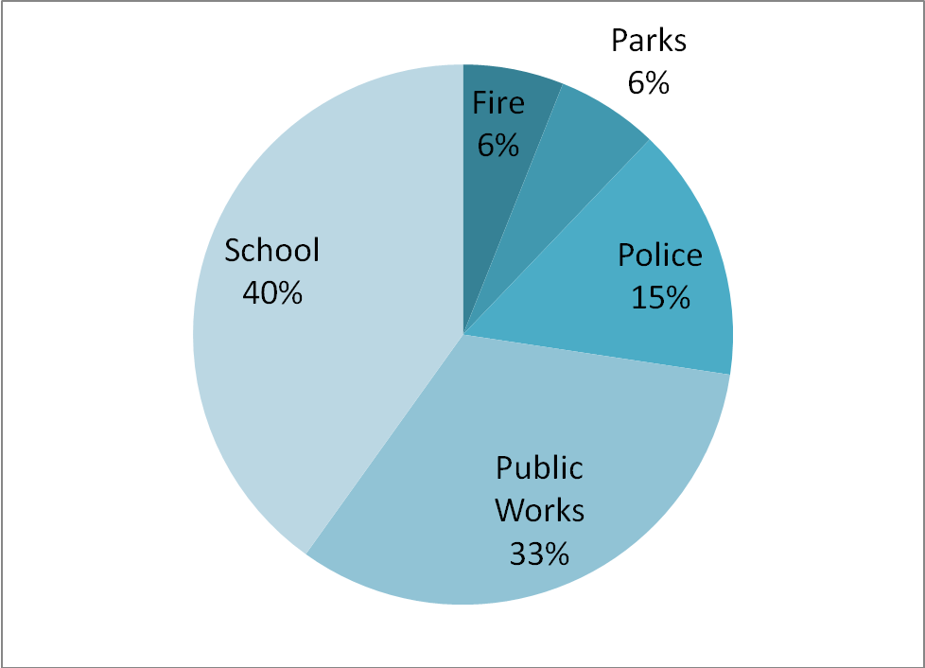
Graph 4b. Comparison of vehicle energy cost by department

The above graphs show the respective energy use and cost of vehicles in each department. Because the emissions graph is the same as the energy consumption graph (in this case, emissions track energy consumption precisely), it is not shown here.

As graphs 4a and 4b show, the school department accounted for the bulk of vehicle energy use and costs in 2007. The school department accounted for $42,275, nearly 7% of municipal energy use, 5% of total municipal energy costs and 6% of municipal emissions. The public works department also accounted for a substantial portion of total municipal energy use and costs – 6% and 4% respectively.

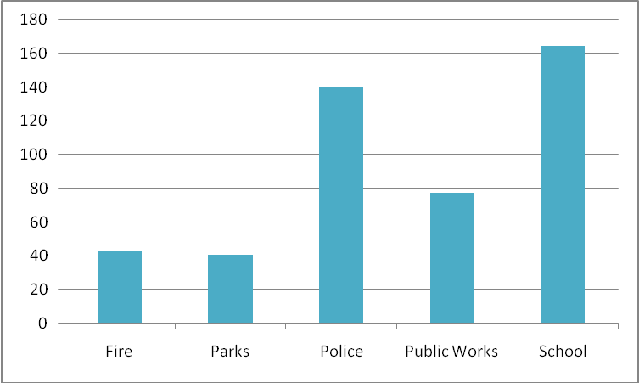
Graph 4c. 2007 average energy use per vehicle (MMBtu) by department

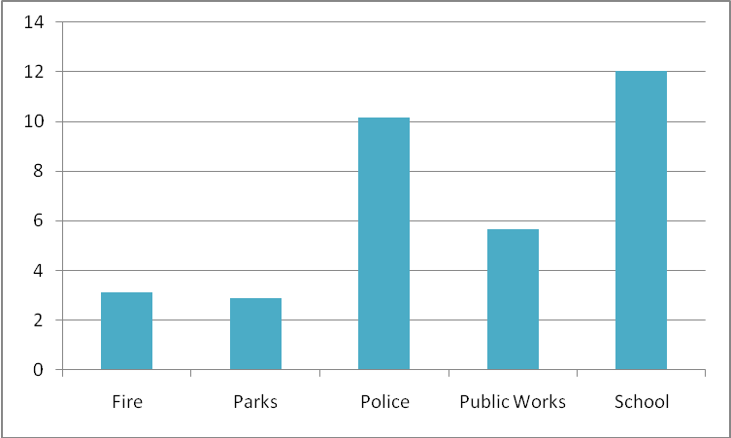
Graph 4d. 2007 average tons of CO₂e per vehicle by department

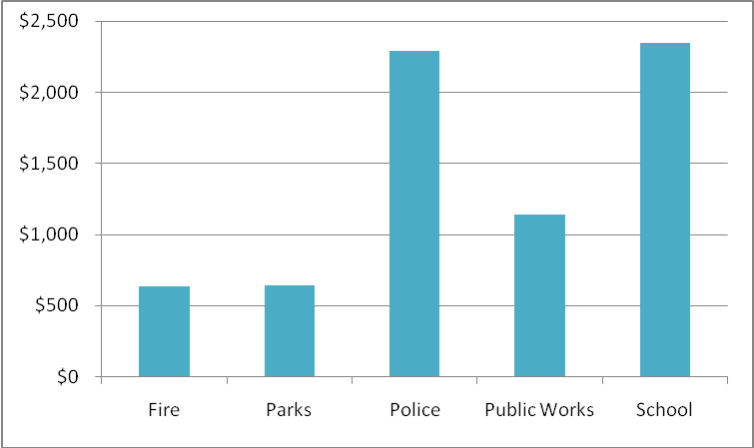.
Graph 4e. 2007 average energy cost per vehicle by department.

The above graphs compare the average energy use, emissions and cost per vehicle within each department. These graphs do not necessarily show how efficient vehicles are – they reflect both efficiency and frequency of use. Energy use per vehicle is useful to see, however, because investments in efficient or cleaner vehicles yield more benefit when those vehicles are intensively used.

The school and police departments had the most energy use, emissions and cost per vehicle in 2007, almost double the public works department, which is the next most energy-intensive per vehicle. More delineation between vehicles will contribute to more insightful analysis in the future. This analysis nevertheless shows the departments in which Cape Elizabeth should focus its efforts in order to realize the greatest gains – upgrading school buses and police cars will likely yield the biggest “bang for the buck.”

Streetlights: Energy Use, Emissions, Costs

Cape Elizabeth tracks multiple street and traffic lights under control of the town. Of these lights, the 499 Town Streetlights were the largest consumers of energy, produced the greatest emissions, and were the most expensive to operate (see Table 5 below). While they accounted for only 2% of Cape Elizabeth’s energy use in 2007, they accounted for approximately 8% of cost, at over $125 per light and $62,605 overall. On average, each light consumed about 1.3 million Btus of energy in 2007, and every 6 lights accounted for just under one metric ton of CO₂e emissions.

Addressing street lights often yields relatively easy cost-savings. As of July 2009, the number of active streetlights in Cape Elizabeth was reduced from 499 to 372. This reduction is expected to save $13,300 a year in energy costs to the town.

Name of Lights | Energy Use (MMBtu) | Portion of Overall Municipal Energy Use (%) | GHG emissions (tons CO₂e) | Portion of Overall Municipal GHG emissions (%) | Energy Cost (US$) | Portion of Overall Municipal Energy Cost (%)
Town Streetlights | 640 | 1.53 | 79 | 2.20 | $62,605 | 7.48
Blinker | 7 | 0.02 | 1 | 0.03 | $424 | 0.05
Shore Rd Blinker | 1 | 0.00 | 0 | 0.00 | $138 | 0.02
Bunker/Fort Williams Light | 6 | 0.01 | 1 | 0.03 | $348 | 0.04
Scott Dyer Rd | 27 | 0.06 | 3 | 0.08 | $1,250 | 0.15
Sign | 1 | 0.00 | 0 | 0.00 | $142 | 0.02
Total | 681 | 1.63 | 85 | 2.37 | $64,907 | 7.76
Table 5. Comparison of street and traffic light energy use, emissions and cost by listing.

Priorities and Recommendations

Cape Elizabeth has done extensive research into potential energy efficiency measures and alternative energy projects. It has also begun to act on several of its plans. The recommendations in this report are based on baseline data from 2007 and may not perfectly reflect current needs or plans. Nevertheless, these recommendations highlight common sense steps that the Town can take. They focus on the areas with the most room for improvement, as identified by the CACP analysis.

General Recommendations for Municipal Energy Savings

- Review existing Comprehensive Plan, Zoning Ordinances, and other town policies for inconsistencies with energy reduction goals.
- Implement a behavioral change program in municipal buildings with municipal employees. Work with the Alternative Energy Committee for guidance to implement this initiative.
- Implement buying strategy of Energy Star equipment and environmentally sensitive office products.
- Evaluate ways to reduce vehicle fleet fuel usage. This can be done by analyzing routes, usage, implementing a strict anti-idling policy, eco-driving education, right sizing, and replacing older vehicles with hybrids and/or alternatively fueled vehicles.
- Begin gathering data for 2010. This will allow for a future comparison to the baseline established in this study and an evaluation of progress towards cost and energy reduction goals. Data gathering could be improved by:
  - Separating the meters for the three schools and the pool, as well as the meters for buildings at Fort Williams
  - Further delineating vehicles by type (diesel large trucks, diesel light trucks, gasoline light trucks, etc).
  - Tracking vehicle fuel consumption and expenditures by month.
- To comply with the Local Government Operations Protocol, add to data tracking:
  - Refrigerants (hydrofluorocarbons used in fire suppression, vehicle and building air conditioning systems, and refrigerators)
  - Per vehicle fuel consumption and expenditure, annual miles traveled (by calendar year), and vehicle year, make and model.

Priorities and Recommendations based on CACP Analysis

Buildings:
1. Within the building sector, address the school electricity consumption first. The schools and pool electricity accounted for over a quarter of municipal energy costs in 2007, and, while shared meters muddy the picture, the Cape Elizabeth Alternative Energy Report from December 2008 demonstrates room for improvement. Cape Elizabeth is already initiating efforts to reduce electricity consumption in these buildings. Fuel switching to alternative fuels such as wood chips could also greatly reduce greenhouse gas emissions from these facilities.

2. Second to the schools and pool, the Town Center Fire and Police Station consumes the most energy, costing just over $45,000 in 2007. It is also one of Cape’s most site energy-intensive buildings, performing worse than the national average for that building class. The Public Works Facility has the third highest energy costs. It is also energy-, emissions- and cost-intensive on a square foot basis, and more energy-intensive than the national benchmark. Examination of these buildings for energy-efficiency improvements should also be a priority.

3. While the Spurwink Church and the Cape Cottage Fire Station only account for half a percent each of total municipal energy consumption, they both performed significantly worse than the national benchmark in 2007. This may be a sign of low-hanging fruit and easy, cost-effective efficiency improvements.
2. The Cape Elizabeth Alternative Energy Committee should conduct a preliminary walk-through of the buildings listed above. Conducting a walk-through audit is a simple process that can provide a significant amount of information about a building. It will serve as an information gathering tool that will allow you to better determine the types of projects that will significantly increase building efficiency and performance. A walk-through audit on these buildings will help Cape Elizabeth choose which building would be optimal for receiving a professional building audit. Information on walk-through tours is available in the NH Handbook Volume 2, chapter 2.9, available for download at www.cleanair-coolplanet.org/for_communities/energyguide.php for the full report.

3. Once a walk-through tour is completed, hire a certified building energy auditor to address the least efficient buildings, as identified in this report and the walk-through tour described above.
4. Ask Cape Elizabeth facility maintenance staff to recommission buildings that continue to perform poorly after walk-through audit recommendations have been implemented. Recommissioning examines the building’s equipment systems, operation and maintenance procedures, and identifies relatively fast and inexpensive improvements that will result in cost savings. In-house staff can typically implement many of the operation and maintenance improvements, often without the purchase and installation of new equipment or technology. Example recommissioning activities include: calibrating building controls such as thermostats and occupancy sensors; adjusting operating schedules to ensure equipment is only on when necessary; checking for leaky or improperly functioning steam traps; and cleaning heat exchanger tubes in condensers, evaporators, and boilers to maintain optimal efficiency. Priority should be given to buildings that do not have an active preventative maintenance program.
Vehicles:
1. Within the vehicle sector, efforts should focus principally on school buses and police cars. School buses are not only the most energetically and financially-costly overall, but they also consume more energy, produce greater emissions, and cost more to operate per vehicle than vehicles in any other department. While the police department accounts for 15% of costs, and 14% of energy use and emissions within the vehicle sector, police cars are also energy- and cost-intensive, costing over $2,250 per vehicle for fuel.
2. The first steps to cleaning up the fleet are to: conduct route analysis on school buses; implement strict anti-idling measures on all vehicles; and provide eco-driving training. Cape Elizabeth already has anti-idling measures in place, but, given that school buses and police cars use so much energy per vehicle, Cape Elizabeth might consider purchasing anti-idling technology to reduce idle time and fuel consumption.
3. Consider purchasing fuel-efficient buses and police cars as replacements for older vehicles. Converting police cars and/or buses to propane or compressed natural gas (CNG) could substantially reduce greenhouse gas emissions. OEM models and aftermarket conversions are available. Converting school buses to B20 would also yield significant emissions reductions, though it might not lead to cost savings. Maine Clean Communities, housed in GPCOG, can provide assistance assessing and purchasing alternative-fueled vehicles and advanced vehicle technology.
Streetlights:
1. Conducting a comprehensive assessment of streetlights may lead to the discovery of “phantom streetlights” – streetlights that the Town pays for but that only exist on paper.
List of Acronyms
CACP Clean Air and Climate Protection (software)
CA-CP Clean Air-Cool Planet
CCP Cities for Climate Protection, ICLEI – Local Governments for Sustainability’s campaign to help local governments reduce emissions
CH₄ Methane
CO₂e Carbon Dioxide Equivalent – a measurement of greenhouse gas emissions that includes other gases such as methane and nitrous oxide.
GPCOG Greater Portland Council of Governments
EPA Environmental Protection Agency
GHG Greenhouse Gas
kBtu Thousand British Thermal Units
MMBtu Million British Thermal Units
N₂O Nitrous Oxide

www.gpcog.org.
For more information on EPA Portfolio Manager Software, see www.energystar.gov/index.cfm?c=evaluate_performance.bus_portfoliomanager. Information on CACP software is at www.cacpsoftware.org.
Population numbers are taken from the 2007 estimates of GPCOG, available at http://www.gpcog.org/data_center/Municipal_Profiles.php.
Square footage was unavailable for some facilities, including the Salt Shed and the Pond Cove Rental Units.
Greenhouse gas inventories conventionally use metric to measure greenhouse gas emissions. Metric tons are used in this report to enable comparison between this and other greenhouse gas inventories, and will be referred to as “tons.”
Cape Elizabeth Town Council Meeting Minutes, August 13, 2007. http://www.capeelizabeth.com/tcminutes/2007/20070813.pdf.
Available at http://www.capeelizabeth.com/council_packets/2009/01-12-2009/Alt_energy_Cape_Final_Report_January_8.pdf
http://iclei.org/index.php?id=800.
The Clean Air and Climate Protection software presents energy use in MMBtus, which is one million British Thermal Units, a common measure of energy consumption (see www.energyvortex.com/energydictionary/british_thermal_unit_(btu)_mbtu_mmbtu.html ).
Fort Williams includes several buildings that share meters.
See http://www.capeelizabeth.com/council_packets/2009/01-12-2009/Alt_energy_Cape_Final_Report_January_8.pdf
Site energy intensity = amount of energy expended per square foot on site to heat, cool, and electrify the area. This measure relates to how much energy is being used on site and fluctuates directly with such variables as how much lighting is being used, how thermostats are kept, etc. It is measured in thousands of Btus per square foot.
EPA provides a national average for buildings of different categories, such as office buildings, fire stations and libraries. Not every building fits neatly into a category, however, so national averages can have limited value.
Greenhouse gas intensity is a measure of emissions from energy use on site. It is measured in tons of equivalent carbon dioxide per thousand square feet.
Clean Air-Cool Planet has created a guide with information on improving the energy efficiency of historic buildings. This can be found at http://www.cleanair-coolplanet.org/for_communities/HDCGuide.pdf
Personal Communication - Cape Elizabeth Police Chief Neil R. Williams
The Local Government Operations Protocol is a standardized set of guidelines that assists local governments in quantifying and reporting GHG emissions associated with their government operations. If national climate legislation allows carbon trading, it is likely that carbon credits will be determined based on analyses that follow this Protocol.
http://www.gpcog.org/Transportation_and_Land_Use/Maine_Clean_Communities.php.

